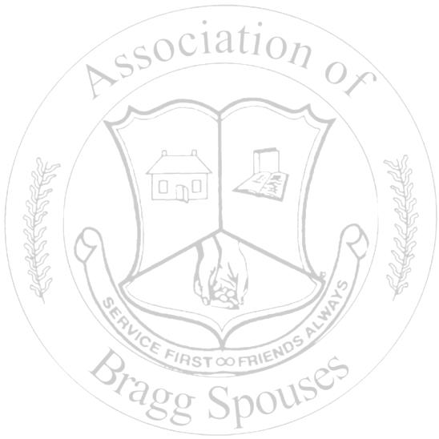
Association of Bragg Spouses - Advertising Agreement

ADVERTISER’S CONTACT INFORMATION:

Name __________________________________________________________________________________

Organization ____________________________________________________________________________

Mailing Address _________________________________________________________________________

Telephone (____) __________________ E-mail Address ________________________________________

The Bits ‘N Bragg is an unofficial publication produced ten times per year by the Association of Bragg Spouses (ABS) at no cost to the US Army. Opinions expressed within are not to be considered an expression of the Club. This publication does not imply an endorsement of any products, services, or firms by the US Army, Fort Bragg, or federal government.

• The newsletter is an online/e-publication; it is not distributed via hard copy. E-mail distribution is reserved for ABS members only. Copies of the newsletter can be viewed at the club website: www.fortbraggabs.org
• ABS reserve the right to decline any advertisements that may be a conflict of interest to the ABS constitution and
by-laws.
• Advertisements will not be placed in a particular or preferential order.

SUBMISSION REQUIREMENTS

• Advertisements can be purchased monthly: A half-page ad is $10/month or a full-page ad is $15/month.
- Payment must be received by the 15th of the month. If payment is not received by the deadline, the advertisement will not be considered for the requested publication date even if the advertisement has been received via e-mail.
• ABS will not be responsible for renewal reminders. Newsletters are published August-May.
• All advertisements must be submitted in electronic format no later than the 15th of the month.
• Advertisements can be changed monthly during the paid segment, as long as the update is received by the deadline. • Advertisements must be e-mailed to ABSnewsletterchair@gmail.com Please put NEWSLETTER
ADVERTISEMENT in the subject.
• Advertisement must be in .jpeg or .pdf format, sized to fit either half-page or full page (portrait layout). All advertisements will be published as is. The editor will not be responsible for design layout, editing, formatting, etc. for any advertisement submitted.
AGREEMENT

I, __________________________________________, have read the above terms and conditions.

I fully understand and agree to my commitment. ____________________________________________
Signature and Date Please circle the months you would like your advertisement to run:

Aug Sept Oct Nov Dec Jan Feb March April May

Half-Page Ad is $10 x _____ (# of months circled) = $________

Full-Page Ad is $15 x _____(# of months circled) = $_________

**********************************************************************************
Please mail agreement and payment to Association of Bragg Spouses
Attn: Newsletter Advertisement
P.O. Box 73625, Fort Bragg, NC 28307

