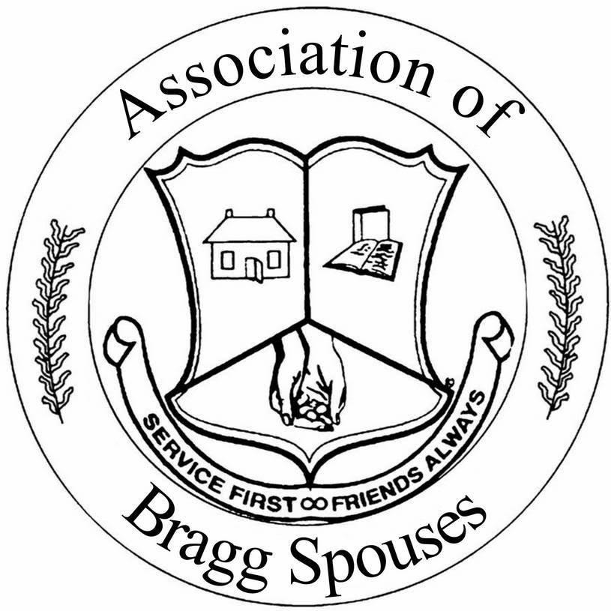 Association of Bragg Spouses
P.O. Box 73625
Fort Bragg, NC 28307
www.FortBraggABS.org

Request for 2022 ABS Welfare Funds

The Association of Bragg Spouses (ABS) is dedicated to assisting various organizations by offering financial support towards special projects, which benefit and/or provide services to the soldiers, DoD civilians, and their families who reside in the Fort Bragg community and the local Fayetteville and surrounding areas. These funds are generated by the ABS and the Bragg Unique Boutique gift shop, along with various fundraising activities that the club organizes. Any organization serving the Fort Bragg population may submit an application to the ABS. It is important that you provide the following information for assistance to be considered:

Section A

NAME OF ORGANIZATION:

DATE: | MAILING ADDRESS:

DATE FUNDS ARE NEEDED: | TOTAL AMOUNT REQUESTED:

POC:  EMAIL: | PH# | ALT PH#
ALTERNATE POC:  EMAIL: | PH# | ALT PH#

EVENT/PROJECT NAME AND DESCRIPTION:

WHO/HOW MANY WILL BENEFIT FROM THIS EVENT/PROJECT:

DOES YOUR ORGNANIZATION PROVIDE SERVICES FOR MILITARY PERSONNEL, THEIR FAMILY MEMBERS AND/OR MILITARY RETIREES? _____YES_____NO

IF YES, WHAT PERCENTAGE OF YOUR CLIENTELE ARE ONE OR ALL OF THE ABOVE_____

IS YOUR ORGANIZATION A GOVERNMENT-FUNDED AGENCY? ______YES______NO

IF YES, HAS THE REQUEST BEEN CONFIRMED AND APPROVED BY THE COMMUNITY COMMANDER? _____YES____NO

PLEASE LIST NEEDS (ITEMIZED LIST OF PRODUCTS, DOLLARS, ETC):

HOW WILL YOU SHOW ABS SUPPORTED YOUR EVENT OR ORGANIZATION?

LIST ANY OTHER COMMUNITY ORGANIZATIONS TO WHICH THIS REQUEST WAS SUBMITTED AND STATUS OF REQUESTS (i.e. GRANTED, PENDING, REJECTED):

PLEASE LIST OR ATTACH DOCUMENTATION, NOT TO EXCEED ONE PAGE, TO SUPPORT YOUR REQUEST. i.e. Date funds required, purchase price of materials, and reason materials needed.
Requests should be very specific.

If your organization is selected to receive ABS welfare funds, who should the check be payable to? (Please print clearly) ___________________________________

Section B

Complete this section only if your organization has received ABS Welfare Funds in the past five years. If your organization has received more than one disbursement of ABS Welfare Funds in the past, be sure to provide details on each project, disbursement, and the status of the monies granted.

Project___________________________________

Amount Received: $__________________________

Date Received:_____________________________

Have the monies granted been spent on the project ____Yes____No
HAVE RECEIPTS BEEN SUBMITTED TO ABS FOR PROJECT? ______Yes _____No
If NO, Why ______________________________________________________________________________

**********************************************************************************************************

Project___________________________________

Amount Received: $__________________________

Date Received:_____________________________

Have the monies granted been spent on the project? ____Yes_____No
HAVE RECEIPTS BEEN SUBMITTED TO ABS FOR PROJECT? ______Yes _____No
If NO, Why_______________________________________________________________________________

**********************************************************************************************************

Project___________________________________

Amount Received: $__________________________

Date Received:_____________________________

Have the monies granted been spent on the project? ____Yes_____No
HAVE RECEIPTS BEEN SUBMITTED TO ABS FOR PROJECT? ______Yes _____No
If NO, Why_______________________________________________________________________________

**********************************************************************************************************

- All funds must be utilized within ninety days from the date of check disbursement. Receipts for the grant request must be submitted to the ABS Welfare Chair POC NLT 90 DAYS FROM THE DATE ON YOUR DISBURSEMENT CHECK. FAILURE TO PROVIDE APPROPRIATE RECEIPTS WITHIN THE TIMEFRAME WILL RESULT IN NO FUTURE GRANTS BEING AWARDED TO THAT ORGANIZATION. Appropriate receipts must match grant requests.
- Appropriate authority approval signature required (i.e. supervisor, commanding officer, principal).
- All information must be provided in order to be considered for funds.

**If the request is approved your POC will be contacted by the ABS Welfare Chairperson.
Submit requests to:
Association of Bragg Spouses
Attn: Welfare Chairperson
P.O. Box 73625
Fort Bragg, NC 28307

All requests for funds must be postmarked by 31 March 2022. Funds will be disbursed in May. Questions may be directed to ABS at abswelfare.fortbragg@gmail.com

Signature:

